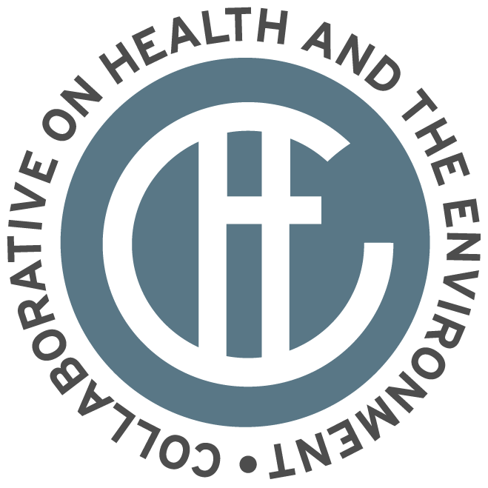

APPLICATION

Environmental Health Science and Healthy Aging Across the Lifespan

Training for Health Advocates, Educators, Activists, & Health Care Professionals
May 7-9, 2013 at Commonweal in Bolinas, California

Return your application to EHTraining@healthandenvironment.org
Priority consideration will be given to applications received by March 29, 2013.
__________________________________________

Name:

Organizations you are affiliated with:

Address:

Phone number(s):

Email:

1. Why are you interested in this training? What would you like to get out of it?

2. How familiar are you with environmental health science? Please describe any formal training, self-education or on-the-job training you have had.

3. What is your experience working with elder populations?

4. Are you currently active in environmental health or justice organizing efforts? Please describe.

5. How do you anticipate you will you apply what you learn during this training?

6. How did you hear about this training?

7. The training, which includes room and board, is offered on a sliding scale of $250–$1,500. Scholarships may be available on a limited basis. Please let us know if you would not be able to attend without a scholarship.

