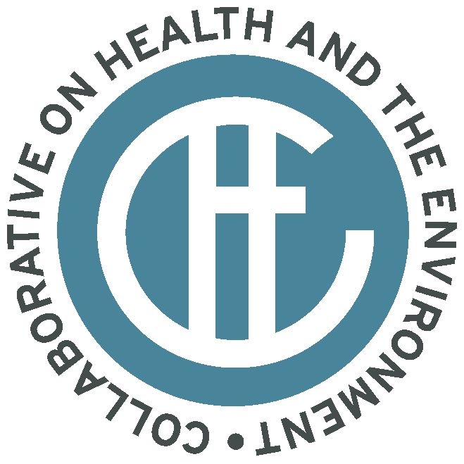
The Collaborative on Health and the Environment
P.O. Box 316
Bolinas, CA 94924
(415) 868-0970
info@healthandenvironment.org

Order Form

Item: CHE National Conference, Environmental Public Health: Science, Medicine, Prevention And Policy, October 13, 2006 DVD set (the conference spans two DVDs). Cost: $15.00 each (includes shipping)

Purchaser:
Name
Organization
Address

Phone
Email

Items: | Quantity: | Amount:
Oct 2006 National Conference DVD set $15.00 (includes shipping) |  | $
Sales Tax (7.75%) California Orders Only
Total |  | $

Method of Payment:

Credit Card
Credit Card Number
Name on Card
Exp Date
Signature
To fax credit card order: Fax order form to Frieda Nixdorf at (415) 868-2230.
To email credit card order: Attach form in an email and send to frieda@healthandenvironment.org.

Check
Please make check payable to Commonweal and note “CHE DVD” in memo line

Check Number

Mail check to:
Commonweal
P.O. Box 316
Bolinas, CA 94929

Questions? Contact Frieda Nixdorf at frieda@healthandenvironment.org or 415-868-0970

