

There is No “War” on Occupational Cancer
President’s Cancer Panel
Public Meeting
New Brunswick, NJ
September 16, 2008
Adam M. Finkel, Sc.D., CIH

[Professor of Environmental and Occupational Health, UMDNJ School of Public Health and Executive Director, Penn Program on Regulation, Univ. of Pennsylvania Law School]

Summary:
The vast majority of human cancers are caused by a combination of host factors (genetic and other predispositions) and “environmental” (very broadly defined) exposures to carcinogenic stimuli. Some of these exposures involve (at least at their outset) voluntary choices (e.g., smoking, high-fat diet). Of the cancers caused by involuntary exposures to pollutants in the air, water, soil, consumer products, and the workplace, occupational cancers are by far the largest source of preventable premature mortality. The two complementary measures of the importance of a hazard are population risk and individual risk; ubiquitous low-level exposures can rank high on the former measure and low on the latter, while the converse can be true of isolated “hot spots” of intolerable exposure to small groups. With respect to occupational cancer, Dr. Landrigan and others have carefully estimated the population risk to be on the order of 20,000 to 40,000 deaths per year, which exceeds all credible estimates of the burden of other “environmental” cancers, and puts this problem on a par with traffic fatalities, homicides, diabetes, and other dominant contributors to early mortality. In individual-risk terms, workplace exposures are also far and away the most unacceptable environmental risks society nevertheless tolerates. While Congress has repeatedly instructed EPA to strive to reduce lifetime excess cancer risks to below one chance in 100,000, workplace cancer risks after OSHA has declared its regulatory “mission accomplished” for a particular carcinogen almost always exceed one chance in 1000. Many as-yet-unregulated workplace risks are of course even larger than this (and since 2001, the current Administration has regulated one substance only, and to a level that presents an “acceptable” excess cancer risk of more than four chances per 100 workers exposed at the new permissible exposure limit).

In the 38 years since the effort officially began, the federal government has done surprisingly little to assess and reduce workplace exposures to carcinogens. I make this observation having served as OSHA’s chief regulatory official in Washington, and later as OSHA’s chief enforcement official in the Rocky Mountain states, during 1995-2005. In my presentation to the President’s Cancer Panel, I will summarize the lack of success by OSHA (and, to a lesser extent, by NIOSH) since 1970 in using the available tools—data collection, standard-setting, enforcement, program evaluation, partnership, and education—to effect reductions in the occupational cancer burden. This pessimistic summary is not to suggest that occupational exposures to carcinogens have increased or remain intolerably high since 1970 – only to suggest that any reductions were likely not causally related to governmental programs, and that we have never collected the information necessary to evaluate these trends and ascribe causality to them.

Two Overarching Observations about Data on Workplace Risks:
- Data from the Bureau of Labor Statistics and from OSHA on trends in “fatal injuries and illnesses” are almost wholly irrelevant to cancer and other chronic occupational diseases. As they are interpreted, OSHA recordkeeping and reporting requirements allow employers not to report virtually all deaths due to chronic disease, because they are by nature not “work-related” in the sense of causally attributable to exposures that occurred in the establishment the employee worked in at the time of his/her diagnosis or death. The “injury and illness” data are injury data only.

- OSHA maintains a complete database on every result of air, bulk, and wipe samples taken during its inspections since 1979—but no one inside or outside the Agency has ever analyzed the complete database to examine current workplace concentrations of toxic and carcinogenic substances, discern trends, explore the influence of geography, firm size, unionization status, and other covariates, or set enforcement priorities! Indeed, it has taken me three years of litigation under the Freedom of Information Act (FOIA) to receive the complete database, but as I am still waiting to receive one missing data field, the observations in this presentation will reflect a preliminary analysis of a small portion of the database.

Concentrations of Occupational Carcinogens and Associated Worker Risks:
- To a first approximation, one might expect concentrations of carcinogens in the occupational environment to be roughly 1000 times higher than in the general ambient environment, simply because EPA generally strives to reduce risks to a level of one in one million where possible, whereas OSHA has steadfastly interpreted the 1980 decision by the Supreme Court in the Benzene case such that risks reduced to one chance per 1000 are acceptably low. I will present preliminary data indicating that the 1000:1 rule-of-thumb indeed does apply for some substances where OSHA standards have been in force for decades, but that the ratio is more like 1,000,000:1 for “newly”-regulated and unregulated substances. Workplace environments may be harder to control to a given air concentration, and workplace risks may to some extent be more voluntarily or at least more consciously borne, but should we be comfortable with 30 minutes’ exposure in the workplace being equivalent to a lifetime of community exposure?
- Table 1 shows individual-risk levels for all of the OSHA carcinogen standards set subsequent to the 1980 Benzene decision.
- A few occupational cancer risks have been measured epidemiologically, without the need for interspecies conversion or high-to-low-dose extrapolation. Some of these risks were actually comparable to the 1 in 6 fatality probability of a round of “Russian roulette.” For example, in the most highly-exposed subgroup of roughly 60 (or fewer) production workers exposed to hexavalent chromium between 1950 and 1992 studied by Park et al. (Risk Analysis, 24(5): 1099-1108), 12 of them developed lung cancer versus 2 expected – an excess risk of nearly one chance in five.
- It is important to note that when OSHA does estimate risks from animal bioassay data, its assumptions and procedures are across-the-board less “conservative” (“conservatism” being a tendency to overestimate risk in the face of uncertainty) than those EPA uses (see Table 2). A substantial literature suggests that on balance, EPA’s assumptions do not introduce significant “conservatism” in any event, but OSHA’s estimates have less, if any, “margin of safety.” And just this past month, the Department of Labor issued a proposal largely designed to reduce the number of years OSHA risk assessors can assume a worker will be exposed to carcinogen during her working lifetime – a change criticized for being unscientific, illogical, and contrary to statute (see attached article from Science).
- Several published case studies (see, e.g., Piltingsrud et al., Applied Occupational and Environmental Hygiene, 18(8): 597-619, Aug. 2003) suggest that when firms install pollution control devices to meet EPA or state environmental mandates, exposures to workers tend to rise (mass balance considerations, changes in indoor ventilation, and other factors can explain this). One of my goals in analyzing the OSHA industrial hygiene database (see above) will be to test this hypothesis statistically, by looking at longitudinal workplace measurements at establishments before and after pollution-control devices were installed.

THE FEDERAL RESPONSE TO OCCUPATIONAL CARCINOGENS
Resources:
- For purposes of comparison, OSHA’s annual budget of roughly $500 million is one-fifteenth that of EPA, and EPA has eight times as many employees as does OSHA. EPA administers more diverse programs, and its decisions affect the entire U.S. population, rather than the roughly 40 percent of Americans who are employed. In absolute terms, it would take OSHA’s federal and state inspectors roughly 100 years to visit each establishment covered by the OSH Act, so it is no surprise that the majority of the establishments in the country have never seen an OSHA inspector.
- Based on extensive experience with OSHA’s budget and programs, I estimate that across-the-board (standard-setting, enforcement, partnership, education, etc.), OSHA devotes roughly 90 percent of its human and financial resources to safety hazards, and only 10 percent to health hazards, despite the fact that more than 80 percent of all occupational premature mortality results from health hazards as opposed to safety hazards.
- Probably the most important single measure of the level of effort OSHA devotes to safety versus health hazards is the number of inspections that focus primarily or exclusively on one type of hazard or the other. OSHA claims (see Table 3; rectangular box) that about 20% of its inspections are “health inspections” (7,647/38,783 = 0.197). During my FOIA litigation, however, OSHA had to generate an estimate of the number of inspections since 1979 where at least one chemical sample was taken. Its estimate of 73,000 such inspections in 30 years (federal and state programs combined) indicates that in fact, in only about three (3) percent of all inspections are health hazards assessed quantitatively (and it shows that the official estimates of roughly 8,000 “health inspections” annually just in the federal program are substantially in error). The large number of “health” inspections is an artifact – OSHA apparently counts any inspection done by a compliance officer hired for his or her health expertise as a “health inspection,” even though these inspectors are spending more and more of their time visiting construction sites and other establishments where no health hazards are anticipated (or where none are sought out).

Data Collection:
- NIOSH last conducted a representative survey of occupational exposures (the National Occupational Exposure Survey) in 1983. In those 25 years, the National Health and Nutrition Examination Survey (NHANES) was conducted in several discrete phases, and has now become a continuous annual survey. It is no exaggeration to say that we now know more about the exposures to toxic substances and resultant body burdens in domestic cats and dogs (Journal of the American Veterinary Medical Association, June 2008) than we do about exposures to U.S. workers.
- I will present preliminary data showing that the number of air and other samples taken by OSHA has fallen dramatically and steadily over the past 20 years.

Standard-Setting:
- In the 28 years since the Benzene decision, OSHA has only issued nine standards that reduce exposures to a carcinogenic substance (see Table 1 below), along with one generic standard on respiratory protective equipment intended to strengthen safeguards for those workers who have to wear them. Seven of these nine were issued between 1992 and 1998, so I argue it is possible for OSHA to be rather productive if it has the will to do so. In this, I agree with Dr. Mirer that the increased analytic burdens on agency risk assessment and economic analysis do not explain the almost-complete breakdown in standard-setting over the past 11 years. I strongly support the full panoply of procedural and analytic requirements for risk assessment as they existed in the late 1990s, and note that it took only 18 months to solicit comment on and produce a full revision of the cancer risk assessment for methylene chloride (MC) during 1996-97 (which broke new ground with pharmacokinetic modeling and which rejected with great specificity the claim that rodent tumors in MC bioassays were physiologically irrelevant to humans).
- In the late 1990s, there were approximately 13 individuals with doctoral degrees working on health rulemaking; all but three of them have left OSHA or been transferred out of rulemaking duties, and to my knowledge at most one or two staff with comparable training have been hired to replace any of them.

Enforcement Targeting:
- As can be seen in Table 3 (ellipse), more than half of all OSHA inspections are “programmed,” which basically involves a system that targets general-industry inspections towards establishments that reported very high “injury and illness” rates the previous year (see above) and construction inspections towards sites that are at the stage of construction where the maximum number of workers are involved. Triggers for “unprogrammed” inspections include complaints from employees, referrals from other agencies, rapid responses to accidents, and occasional follow-up of previous inspections where many violations were found. All of these triggers bias the system towards safety inspections and away from health inspections; “injury and illness” rates exclude illnesses, complaints can certainly involve chronic exposures but there is a certain Catch-22 in relying on that, etc.
- OSHA has the ability to target inspection resources via “Local Emphasis Programs,” which in theory allow one or more Area Offices (there are between 1 and 9 Area Offices per state) to deploy more inspectors towards hazards of special intensity or interest. I examined the 113 LEPs OSHA was conducting as of April 2008, and found that only 16 of them (14%) clearly involved health hazards, and only one (a hexavalent chromium program in the mid-Atlantic region) that clearly involved a carcinogenic hazard (the other 7 health LEPs included three on the sensitizer MDI (methylene diphenyl isocyanate), six on silica (which is a carcinogen, but OSHA emphasizes the silicosis endpoint), two on noise, etc.). Seventy-four LEPs clearly involved safety hazards only, and the remaining 23 probably address safety only (e.g., “warehouse and refuse handlers and haulers”).
- I will present preliminary information from an analysis of the relationship between the number of methylene chloride samples OSHA has taken each year and the proportion of samples the previous year that exceeded the Permissible Exposure Limit, to suggest that even when increased emphasis on health would be expected to yield many violations—a.k.a. opportunities to abate high exposures to carcinogens—OSHA may either fail to adapt to its findings or may consciously resist them.

Enforcement Results:
- OSHA’s Website (http://osha.gov/pls/imis/industryprofile.html) allows the public to see how many inspections have been conducted during a recent fiscal year (Oct. 2006- Sept. 2007) where particular OSHA standards have been violated. The numbers suggest that very few such inspections have been carried out for the common health standards that many people might think are a focus of OSHA activity. For example, during this time period nationwide there were: 173 inspections where violations of any of the substances (a list of over 400 chemicals) on OSHA’s “Z-Table of Permissible Exposure Limits” were found, 77 inspections with asbestos violations, 74 for chromium, 71 for methylene chloride, 52 for formaldehyde, 24 for cadmium, 3 for benzene, and 2 for ethylene oxide. All these violations together resulted in approximately $1 million in monetary penalties—all firms, all substances, in all 26 states with federal OSHA programs. Compare this to one commonly-cited (but not the most-cited) safety standard—under “general requirements for scaffolds,” there were 4,050 inspections with violations in FY 2007, and over $10 million in penalties. Until I analyze the entire industrial hygiene database I received under FOIA, I will not be able to gauge whether the low numbers of violations reflect few inspections or reflect many inspections documenting widespread compliance with OSHA health standards (although I hasten to add that because of the high risk levels associated with OSHA PELs, compliance is not tantamount to protection). However, based on some preliminary information about the percentage of health inspections with violations, I believe the small numbers of “hits” reflect the paucity of inspections.
- OSHA also has the statutory authority to issue “General Duty Clause violations” if an employer knowingly subjects workers to serious and preventable workplace hazards even where no specific standard (or an obviously inadequate standard) exists. But an analysis of data from OSHA’s Website shows that this authority may as well not exist with respect to carcinogens and other toxicants. The search function at http://osha.gov/pls/imis/generalsearch.html allows word-searching of the text of all General Duty citations for the past 10 years. Searching under “carcinogen” revealed only ONE citation during that time in the entire U.S. (for exposure to β-estradiol in a pharmaceuticals factory). Searching under “cancer” showed SIX citations in 10 years nationwide (two for excessive exposure to sunlight, and one each for chemotherapy agents, wood dust, dioxins, and cytotoxic drugs). Searching for “TLV” (the “Threshold Limit Values”® that the American Conference of Governmental Industrial Hygienists publishes) showed 30 citations in ten years, but most of these were for heat stress or ammonia exposures.

Observations about the Lack of Emphasis on Occupational Health:
In my experience, several plausible explanations can be offered for OSHA’s relatively greater interest in safety hazards over health hazards:
- Especially in recent years, the leadership of the Agency has emphasized that its “inspection numbers” (that is, the number of inspections conducted) have remained constant despite concerns about diversion of resources to cooperative programs. Given that a health inspection ties up an inspector for at least twice the number of hours as does a safety inspection (see Table 3; dotted rectangle—and health inspections involving serious industrial hygiene sampling can take many times as long as this average), inspectors who want to meet their unwritten quotas learn to shun complicated health inspections.
- I applaud Congress for passing the Government Performance and Results Act (GPRA) in 1993; it properly focuses Agency attention on measures of outcome rather than of activity. However, OSHA has fallen prey to the pitfall of “what gets measured gets done.” Fatal accidents can be enumerated as they happen, whereas premature deaths from occupational disease could only be tallied with a much-improved medical and analytic infrastructure (see below). A new safety standard can be rolled out at a press conference featuring workers who were saved by better controls (“a net saved me from a fatal fall, and everyone should have one”)—but there are no identifiable witnesses who have been spared from contracting occupational cancer.
- Many of the most senior career executives at OSHA have been there since the 1970s or 1980s, and came from safety backgrounds. Several appointed heads of OSHA (under both Republican and Democratic administrations) had impressive occupational health expertise, but were never able to affect cultural and personnel changes through the ranks.

PROPOSED SOLUTIONS:
In my presentation, I will briefly offer several ideas for jump-starting a federal response to occupational carcinogen exposure that is actually designed to effect significant risk reductions:

- Congress should enact a “Workplace Clean Air Act” modeled on the air toxics section (§112) of the Clean Air Act Amendments (CAAA) of 1990. In 1989, OSHA tried to set new Permissible Exposure Limits (PELs) for about 420 substances without conducting any quantitative risk assessment (in clear contravention of the Benzene decision); when a federal court struck down this rulemaking in 1992, the PELs reverted to the values based on TLVs from 1968 and earlier, where they remain today. In my opinion, risk assessment is not the time-limiting factor impeding an Agency that might have the political will to update the PELs; economic feasibility analysis is. When faced with decades of very slow progress by EPA issuing risk-based standards, Congress in the CAAA created a technology-based regime, under which EPA has since issued hundreds of standards governing air toxics emissions from industrial processes. OSHA could set PELs based on a combination of technology-based and risk-based criteria: (1) like it did in the CAAA, Congress could determine that if a significant minority of other firms in a particular industrial sector had already installed a particular control technology or met a particular emissions limitation, that level of performance would de facto be “feasible” and no further proof would be necessary; and (2) unlike the CAAA, Congress could make OSHA meet the additional constraint of showing that the feasible technology did not reduce occupational risk below the level of insignificance (I suggest that 1 chance in 10,000 (10⁻⁴) would be a reasonable benchmark). Under such a regime, I believe that OSHA could effectively regulate all of the industrial processes exposing workers to intolerable levels of the most important substances on the original list of PELs (plus several more (e.g., diacetyl) that have become important in recent years), within the next 6-8 years (sooner if more resources were provided).
- Through reorganization, all of the occupational health functions of the federal government should be centralized, preferably somewhere other than the Department of Labor. EPA and OSHA both (should) seek to influence the same industrial processes, but often do so via duplicative or even contradictory (see above) regulations, and cannot engage stakeholders in discussions about prevention, product stewardship, and inherently safer technologies as long as they have rivalry rather than cooperation. OSHA could function effectively as an occupational safety agency.
- If this reorganization does not occur, DOL should at least re-establish a separate Directorate of Health Standards to promulgate occupational health rules. In 1999, the health and safety rulemaking divisions were combined, and one executive position eliminated—one of the factors that contributed to the near-total collapse of health rulemaking.
- OSHA should resurrect and promulgate the “generic safety and health program standard,” under which every employer would have to establish its own system for detecting and evaluating hazards, much like the HACCP system works in food safety.
- OSHA should penalize employers who under-report injuries, and amend the recordkeeping system so that chronic diseases should be reported (on a no-fault basis, simply so that the employer at the time of diagnosis would report with no presumption that the disease arose under his watch).
- States should require that occupational codes be listed on death certificates.
- Congress and the Office of Management and Budget should clarify that GPRA performance measures do not have to be all the way “downstream” to epidemiologic findings. Careful documentation of reductions in exposures to hazardous substances IS evidence of success, even if exposure is “intermediate” on the pathway to health effect.
- Congress should fund a large representative exposure survey in the U.S. workplace, and ancillary studies of the body burdens of persistent pollutants in U.S. workers.
- OSHA should address selected occupational health problems via the mechanism of “enforceable partnerships” we pioneered in the late 1990s—rather than setting exposure limits, working with producers, labor unions, and firms who purchase and use hazardous products to establish codes of practice. For example, we established a partnership with all the manufacturers of fiberglass insulation and the major associations of installing contractors, under which the manufacturers wrote a code of practice (including a reduced exposure limit) and provided protective equipment, training videos, industrial hygiene sampling, and other services to their customers to help them lower exposures in the field. This partnership (and several others established in that era) was to be accompanied by a statement from the industries involved that they acknowledged the terms of the code of practice as their General Duty under the OSH Act.
- Congress should substantially increase the maximum monetary penalties OSHA can assess (see Table 3; dashed rectangle), especially in cases where accidents and overexposures stem from willful violations of standards or the General Duty Clause.

TABLE 1
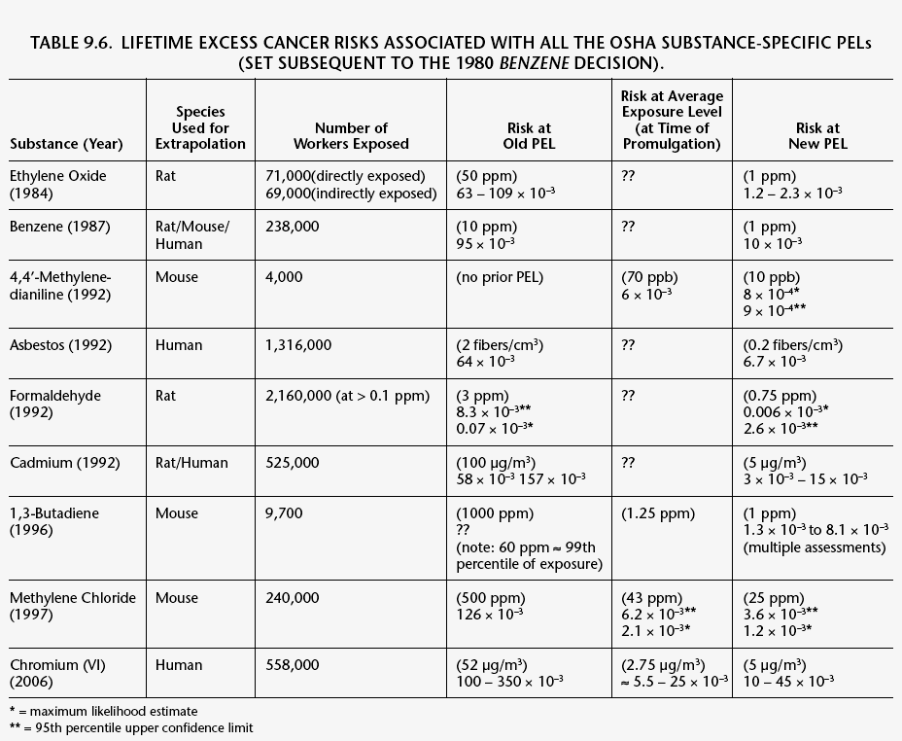

[Table 9.6 in Finkel, A.M. and P.B. Ryan (2007). Risk in the Workplace: Where Analysis Began and Problems Remain Unsolved. Chapter 9 (pp. 187-237) in Risk Assessment for Environmental Health, Association of Schools of Public Health (M.G. Robson and W.A. Toscano, eds.), John Wiley & Sons Inc.]
TABLE 2

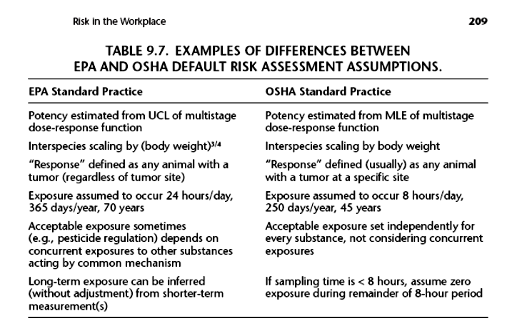

[Table 9.7 in Finkel, A.M. and P.B. Ryan (2007). Risk in the Workplace: Where Analysis Began and Problems Remain Unsolved. Chapter 9 (pp. 187-237) in Risk Assessment for Environmental Health, Association of Schools of Public Health (M.G. Robson and W.A. Toscano, eds.), John Wiley & Sons Inc.]
TABLE 3

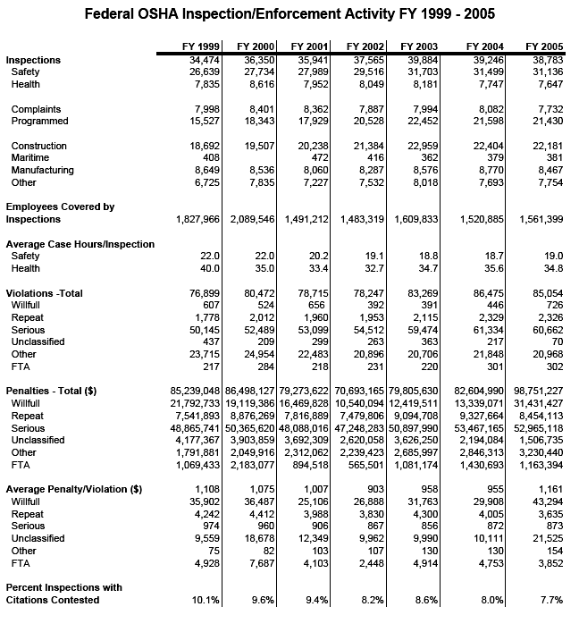

[From “Death on the Job: The Toll of Neglect,” AFL-CIO, 15th ed., April 2006.]

EPA estimates, for example, that approximately 3,000 cancer deaths per year nationwide are attributable to community exposure to all air toxics combined (excluding radon in homes).
Several recent comprehensive studies have documented significant under-reporting of injury data (see, e.g., Boden and Ozonoff, Annals of Epidemiology 18(6): 500-506, June 2008), so it is uncertain how useful these data are even to gauge trends in injury alone.
The Court said that somewhere between risk levels of 1 in 1000 and one in one billion, the boundary of insignificant risk must be reached (see, e.g., Finkel and Ryan, 2007, citation in Table 1) – the Department of Labor lawyers have consistently maintained since 1980 that the uppermost end of this range is their preferred stopping point.
The Agency unsuccessfully tried to argue that in a few percent of this subset of all inspections, the employer had asked that the sample result be kept confidential as a trade secret, but it claimed that OSHA had failed to mark any of these requests as such in the database, and thus should not be ordered to release any sample results whatsoever. The 2007 court order said that OSHA had to go back to the original paper data sheets (73,000 of them, by OSHA’s own estimate) if it wanted to look for any such trade-secret requests; OSHA than instead petitioned the Court to order it to release the entire database without having to conduct such a search.
OSHA can count multiple inspections on a single construction site, one for each different contractor where violations are recorded—so the emphasis on number of inspections rather than other measures of enforcement arguably accounts for some of the trend towards more and more construction activity at OSHA.

